Dear Dad and Mom and Michael:

I’m sorry I ruined your lives and also I feel real upset about pouring that bottle of maple syrup into your DVD player. My bad.

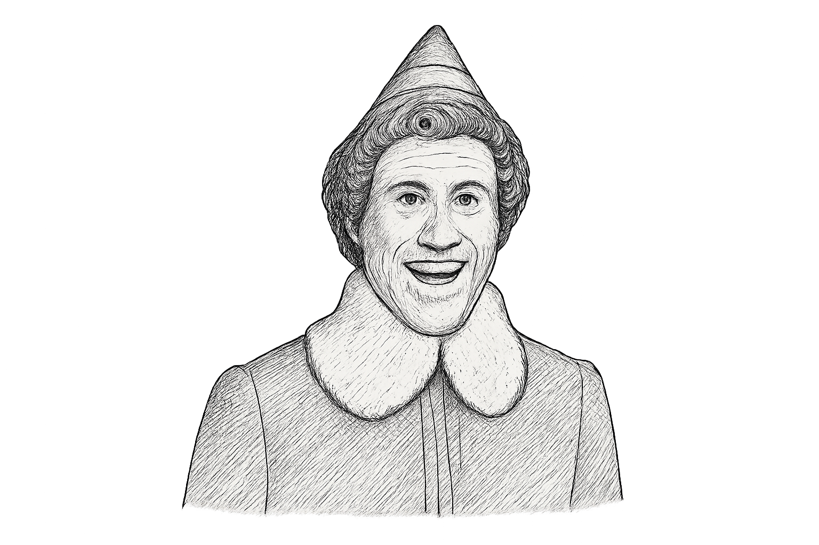I don’t belong here with you. I don’t belong at the North Pole, either.

I’ll never forget you.

Love and goodbye, Buddy.

P.S. Merry Christmas!